# Logo Tools for Teachers Smarter BalancedPlanning for Remote Learning and the Formative Assessment Process

Use this template to adapt a [Tools for Teachers](https://smartertoolsforteachers.org/) resource for a remote learning context. This template is designed to support educators' integration of the Smarter Balanced Remote Learning Framework and the formative assessment process for remote teaching and learning.

## 3 STEPS

1. Review your selected [Tools for Teachers](https://smartertoolsforteachers.org/) Resource.
2. 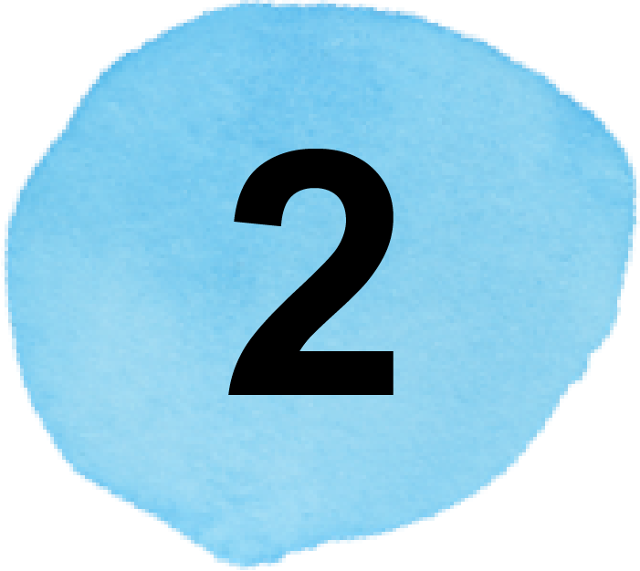Review the Smarter Balanced Remote Learning Framework to find new ideas for engagement during remote learning.
3. Adapt the Step-by-Step section of the lesson using the template.

**RESOURCE NAME**   
 type here

**GRADE**   
 type here

**CONTENT AREA**   
 type here

## FRAMEWORK FOR REMOTE TEACHING AND LEARNING

## Within the four stages of the Formative Assessment Process — Clarify, Elicit, Interpret, and Act — this resource identifies Key Considerations for Teaching: Plan for Engagement, Instruct for Equity, and Design for Learner Well-being.



## 

## Step 1 — Review Your Selected Resource Find a lesson you want to teach and review it to think about how it will work in a remote setting. *

Now that you have your resource, prioritize learning for the remote context using the Smarter Balanced Remote Learning Framework.

* What elements of this lesson may not be feasible in a remote learning context?   
  (e.g., instructional strategies, step-by-step activities)

type here field






type here

* What adjustments might I need to make to the learning goals and success criteria?

 type here

* What is the most essential learning in this lesson and which activities will have the most impact in the remote learning context?

 type here

## Step 2 — Review the Smarter Balanced Remote Learning FrameworkThe Smarter Balanced Remote Learning Framework identifies conditions that can support students to engage in remote learning and articulates strategies and example teacher actions in three domains: Engagement, Equity, and Well-Being.

I understand how the conditions for engaging students can improve the remote learning experience for my students. (pg. 1)

I can plan instruction using the three domains: Engagement, Equity, and Well-Being. (pg. 2)

 I can use the formative assessment process in remote instruction to help students meet their learning goals. (pg. 4–11)



____________________________

*Whenever you see  please hover your cursor over it without clicking to see more information.

## Step 3 — Adapt the Lesson Using the Smarter Balanced Remote Learning Framework and the Formative Assessment Process Use the Smarter Balanced Remote Learning Framework to reflect on the conditions for engaging students, enhancing engagement, equity, and well-being, and use this template to document adjustments to the lesson plan.

Use the Smarter Balanced Remote Learning Framework to reflect on the conditions for engaging students.

### Conditions for Engaging Students in Remote Learning

Student engagement is essential for successful remote learning. The conditions listed below support students to fully engage in learning.

1. **Create a Community of Learners**:  
   Students feel welcomed to actively engage in a remote learning community.
2. **Recognize Personal Assets as Foundation:**   
   Students’ identities and personal knowledge are the foundation for their own learning, and students are encouraged to share and draw from their own experiences and cultural and social assets. Teachers use this knowledge to help students meet their learning goals.
3. **Promote Student Agency:**   
   Students’ interests and choices are present and prioritized, and students are supported to manage their own learning.
4. **Provide Opportunities to Make Thinking Visible:**   
   Students have multiple opportunities and methods to make evidence of their thinking visible to teachers and peers.
5. **Provide Meaningful Interaction with Teachers and Peers:**   
   Students have multiple opportunities for meaningful interaction with teachers and peers both in real time (on synchronous tasks) and when working independently (on asynchronous tasks).

### Reflection Questions

### What conditions for engagement are going well in my remote teaching and what are areas for growth?

type here



**How does this lesson offer an opportunity to strengthen one or more of these conditions?**

 type here

### Plan for Remote Instruction to Enhance Engagement, Equity, and Well-Being

| **Formative Assessment Process**  * Locate the Formative Assessment Process section at the end of the Tools for Teachers resource. * Paste the information into this column as a reference to guide your planning. * Add additional rows as needed. | **Adapt instruction for Remote Learning** Remote Learning Framework pg. 4–11  * Write down the changes you will make to adapt the lesson to a remote context, documenting specific actions within each component of the formative assessment process. * Make note of the specific actions you can take to enhance engagement, equity, and well-being (using the teacher actions in the Remote Learning Framework). |
| --- | --- |
| LESSON PREPARATION | LESSON PREPARATION FOR REMOTE INSTRUCTION type here field type here |
| CLARIFY type here field type here | type here field type here |
| ELICIT type here field type here | type here field type here |
| INTERPRET type here field type here | type here field type here |
| ACT type here field type here | type here field type here |

