# Logo Tools for Teachers Smarter BalancedPlanning for Remote Learning and the Formative Assessment Process

# (Reading Grade 3 Example)

This resource provides an example that illustrates how the Smarter Balanced Remote Learning Framework can be used to adapt a Tools for Teachers resource to a remote learning environment using a template designed to support this process. A blank template is available here.

## 3 STEPS

1. Review your selected [Tools for Teachers](https://smartertoolsforteachers.org/) Resource.
2. 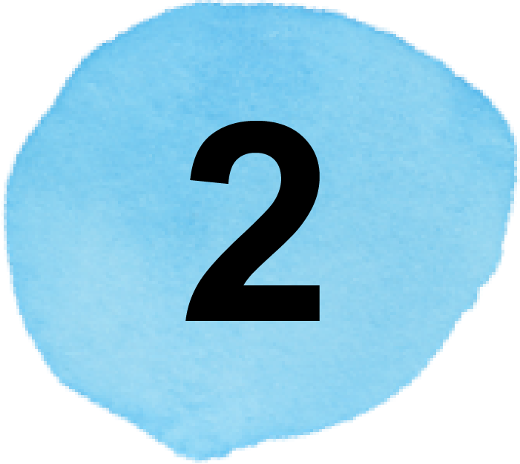Review the Smarter Balanced Remote Learning Framework to find new ideas for engagement during remote learning.
3. Adapt the Step-by-Step section of the lesson using the template.

**RESOURCE NAME**   
 Lessons from a Story by Krystal Murdoch https://smartertoolsforteachers.org/resource/1249

**GRADE**   
  3

**CONTENT AREA**   
 Reading

## FRAMEWORK FOR REMOTE TEACHING AND LEARNING

## Within the four stages of the Formative Assessment Process — Clarify, Elicit, Interpret, and Act — this resource identifies Key Considerations for Teaching: Plan for Engagement, Instruct for Equity, and Design for Learner Well-being.

## 

## Step 1 — Review Your Selected Resource Find a lesson you want to teach and review it to think about how it will work in a remote setting. *

Now that you have your resource, prioritize learning for the remote context using the Smarter Balanced Remote Learning Framework.

* What elements of this lesson may not be feasible in a remote learning context?   
  (e.g., instructional strategies, step-by-step activities)

type here field






All of the elements of the lesson are feasible using online classroom collaboration tools and response tools.

* What adjustments might I need to make to the learning goals and success criteria?

 No adjustments to the learning goal and/or success criteria are needed.

* What is the most essential learning in this lesson and which activities will have the most impact in the remote learning context?

 The essential learning is reading a story and being able to identify the central theme from several examples of a central message, moral, or theme based on evidence in the story. Then, explain the rationale for the decision to receive peer feedback.

## Step 2 — Review the Smarter Balanced Remote Learning FrameworkThe Smarter Balanced Remote Learning Framework identifies conditions that can support students to engage in remote learning and articulates strategies and example teacher actions in three domains: Engagement, Equity, and Well-Being.

I understand how the conditions for engaging students can improve the remote learning experience for my students. (pg. 1)

I can plan instruction using the three domains: Engagement, Equity, and Well-Being. (pg. 2)

 I can use the formative assessment process in remote instruction to help students meet their learning goals. (pg. 4–11)



____________________________

*Whenever you see  please hover your cursor over it without clicking to see more information.

## Step 3 — Adapt the Lesson Using the Smarter Balanced Remote Learning Framework and the Formative Assessment Process Use the Smarter Balanced Remote Learning Framework to reflect on the conditions for engaging students, enhancing engagement, equity, and well-being, and use this template to document adjustments to the lesson plan.

Use the Smarter Balanced Remote Learning Framework to reflect on the conditions for engaging students.

### Conditions for Engaging Students in Remote Learning

Student engagement is essential for successful remote learning. The conditions listed below support students to fully engage in learning.

1. 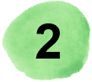**Create a Community of Learners**:  
   Students feel welcomed to actively engage in a remote learning community.
2. **Recognize Personal Assets as Foundation:**   
   Students’ identities and personal knowledge are the foundation for their own learning, and students are encouraged to share and draw from their own experiences and cultural and social assets. Teachers use this knowledge to help students meet their learning goals.
3. 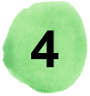**Promote Student Agency:**   
   Students’ interests and choices are present and prioritized, and students are supported to manage their own learning.
4. **Provide Opportunities to Make Thinking Visible:**   
   Students have multiple opportunities and methods to make evidence of their thinking visible to teachers and peers.
5. **Provide Meaningful Interaction with Teachers and Peers:**   
   Students have multiple opportunities for meaningful interaction with teachers and peers both in real time (on synchronous tasks) and when working independently (on asynchronous tasks).

### Reflection Questions

### What conditions for engagement are going well in my remote teaching and what are areas for growth?

I have a group of students who need assistance in reading. Included in this group are 3 students who are English learners. Because of their current English language proficiency levels, sometimes these students are not fully engaged in the conversation in the remote setting, particularly when we focus on text-based discussions.



**How does this lesson offer an opportunity to strengthen one or more of these conditions?**

 This lesson has a small group discussion opportunity where I can work with the students to help them participate more fully.

### Plan for Remote Instruction to Enhance Engagement, Equity, and Well-Being

|  |  |
| --- | --- |
| **Formative Assessment Process**  * Locate the Formative Assessment Process section at the end of the Tools for Teachers resource. * Paste the information into this column as a reference to guide your planning. * Add additional rows as needed. | **Adapt Instruction for Remote Learning** Remote Learning Framework pg. 4–11  * Write down the changes you will make to adapt the lesson to a remote context, documenting specific actions within each component of the formative assessment process. * Make note of the specific actions you can take to enhance engagement, equity, and well-being (using the teacher actions in the Remote Learning Framework). |
| LESSON PREPARATION | LESSON PREPARATION FOR REMOTE INSTRUCTION  * Create a shared folder (e.g., in Google Drive) for each group. * **Equity**: When making group assignments, consider matching students who participate without cameras with students who can engage well with peers participating only verbally. * In each folder, create a collaborative document (e.g., Google Doc) with activity instructions, time constraints, and the umbrella icons pasted into the document. * Add the stories each group will read to the folder. * **Equity**: Consider if different stories may have more relevance for your students. * **Equity**: Prepare translations of stories and have online dictionaries and glossaries available for English Learners. * Ensure all students have access to edit the folder and all documents. * Assign students to four groups, and plan to send them into breakout rooms for the group activity. |
| CLARIFY To clarify the intended learning, the teacher will conduct a Think-Pair-Share. This will enable students to discuss the learning goals and success criteria in their own words. You will know when students understand the learning goal and success criteria when students can explain the expectations using their own words or with the sentence stems. If students are struggling, you can discuss specific vocabulary terms within the goals and success criteria. | **Synchronous (whole group):**   * Meet with the whole class via video meeting platform (e.g., Zoom), and share the learning goal, success criteria, and the sentence frames in a slide. * **Engagement**: Provide clear instructions to students about how they will engage in this lesson, the amount of time allocated for each activity, and the specific roles they will play in the collaborative discussion. * **Engagement**: Collaborate with support staff who work with students with special needs to support students during the discussion. * Ask students to think individually and complete the sentence frames using the chat box. Scan the responses. Respond verbally to clarify misconceptions or probe student thinking. * **Well-Being**: Affirm student participation in shared goal setting by providing positive responses to student reflections and making connections between students’ ideas. |

|  |  |
| --- | --- |
| ELICIT — LEARNING The teacher will elicit evidence by posing questions to the whole group. Students will Think Aloud to collaborate and share. Look for students’ responses that allude to understanding that the central message, lesson, or moral is the idea that the author is trying to convey to the reader. It is important that students understand that the central message is different from the main idea of a story. (Main idea is what the story is mostly about. Central message, lesson, or moral is what the reader can learn from the story.) When students are able to verbalize and share what a central message, lesson, or moral is and how it conveys an idea to the reader, they are ready to move on to the learning activity. | **Synchronous (whole group):**   * Post the discussion questions on a slide or document visible on a shared screen and conduct the Think Aloud verbally. * Allow students to share feedback verbally and in writing (either in the chat box or directly in the document if using a collaborative tool like Jamboard). * **Equity**: Allow students to use multiple methods to participate in discussions verbally, through the chat, or by posting ideas in collaborative tools (e.g., Jamboard). |
| INTERPRET — LEARNING ACTIVITY The teacher will monitor the room while students complete the Sorting Activity. During this activity, the teacher will interpret evidence of student learning by observing the students’ placement of stories under specific umbrellas. Look for keywords that are identified by students to place them. If students are struggling to determine the message, point them to the questions from the board that they could ask themselves. | **Synchronous (whole group):**   * Introduce the activity in the whole group video meeting room, and provide detailed instructions while sharing a slide with the guiding questions. * Provide detailed instructions about the asynchronous work. * **Engagement**: Model explicitly how to use all the tools they will use independently and in breakout groups. * **Equity**: Provide instructions for all activities verbally and visually to ensure that students have visible instructions and prompts throughout the independent work and breakout room discussion.   **Asynchronous:**   * Provide written instructions for independently reading and annotating assigned stories as well as digital versions of the stories in your preferred classroom platform (Google Classroom, SeeSaw, etc.). * Ask students to read and independently highlight the story using an embedded highlighting tool (e.g., in Word, PDF, Google Docs). * Ask students to have access to their highlighted stories when they join the synchronous meeting.   **Synchronous (whole group and small group):**   * Meet with the whole class via video meeting platform and provide detailed instructions for the sorting activity in breakout rooms. * Demonstrate how to access materials and how to mark up the collaborative worksheet (Google Doc). * Send students to pre-assigned breakout groups. * **Engagement**: Use breakout room visits to engage students and support peer discussion. * "Pop into breakout rooms and use strategic questioning to check on student engagement and clarify any confusion." * **Equity**: While visiting breakout rooms, observe and ask direct questions about how technology tools have impacted student learning; interpret evidence of learning with this information in mind and plan to gather additional evidence if technology or other barriers impacted students’ ability to learn and show evidence of their learning. * **Well-Being**: Encourage students to draw on and share their personal, social, and cultural strengths. * Ask students to post the completed collaborative worksheet to the online classroom management tool (e.g., Google Classroom or SeeSaw). |
| ACT — LESSON SYNTHESIS Using evidence from the Sorting Activity, provide support on the student worksheet to students who appeared to struggle with the concept of central messages, lessons, or morals. These students could be pulled into a small group or partnered with another student. If the majority of students seem to struggle with understanding, consider doing the student worksheet as a whole group or in small group rotations. Completing this as a whole group would allow students to have more thinking partners and supervision by the teacher. | **Synchronous (whole group):**   * At a specified time, pull students from breakout rooms back to the whole group meeting room. * Ask each group to share their thinking about their story and the umbrella under which they placed it. Find each group’s story with words highlighted in the shared folder (e.g., Google Drive), and ask the group to explain why the story fits under the umbrella and share while the group is presenting. * **Engagement**: Provide opportunities for students to offer feedback on each group following the breakout groups. * Use the guiding questions previously shared with the class to help the group share why they chose a story to be placed under the umbrella. * **Engagement**: Prompt students to explain how they contributed to the group discussion with clarifying questions and evidence from the story. * **Well-Being**: Ask questions that encourage students to make connections to their own identity development and experiences. * Show the whiteboard tool with the responses from earlier in the lesson. Ask students to add additional comments and information * **Well-Being**: Provide specific feedback focused on collaboration and peer discourse, highlighting specific strengths that students can build on and specific things they can do to improve. * Provide the additional worksheet for independent practice through the classroom platform, and introduce it to students. |
| LESSON FOLLOW-UP | **Synchronous (small groups):**   * Identify students who need additional practice based on their participation and evidence of understanding in the breakout room collaborative discussions. * **Equity**: Reflect on group dynamics in the breakout rooms to inform grouping in upcoming instruction. * Meet with individuals or small groups using breakout meetings for a Read Aloud of parts of the story to help identify the parts in the story that could help them infer what the author wants them to understand. * **Well-Being**: Check in with the adult support staff and families to get their feedback on the engagement and learning of students with disabilities. |